1 | 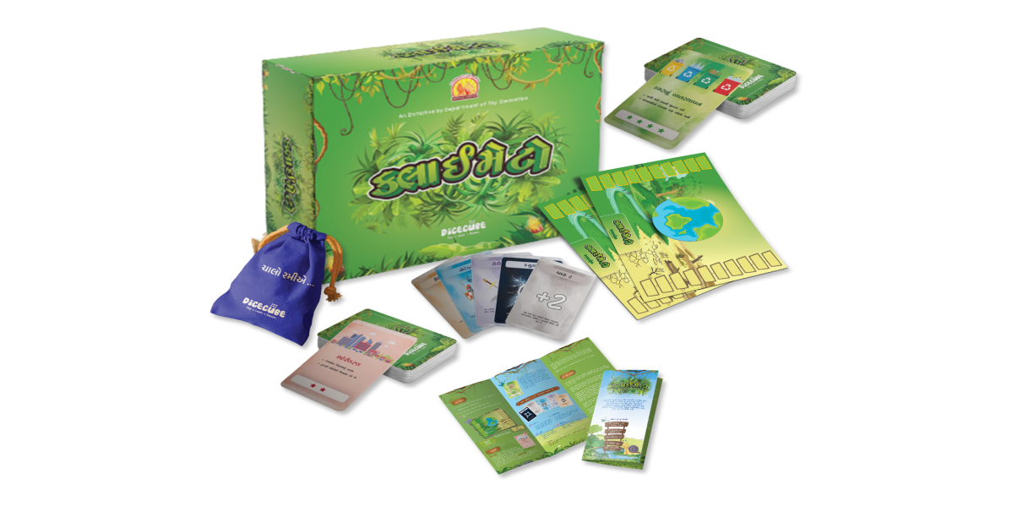 | Climato  Age Group : >08 Years  Learning Outcomes:  - Environmental awareness  - Know various components of environment  - Know about environment pollutants and pollutants determinants  - Decision-making  - Strategic thinking
2 | 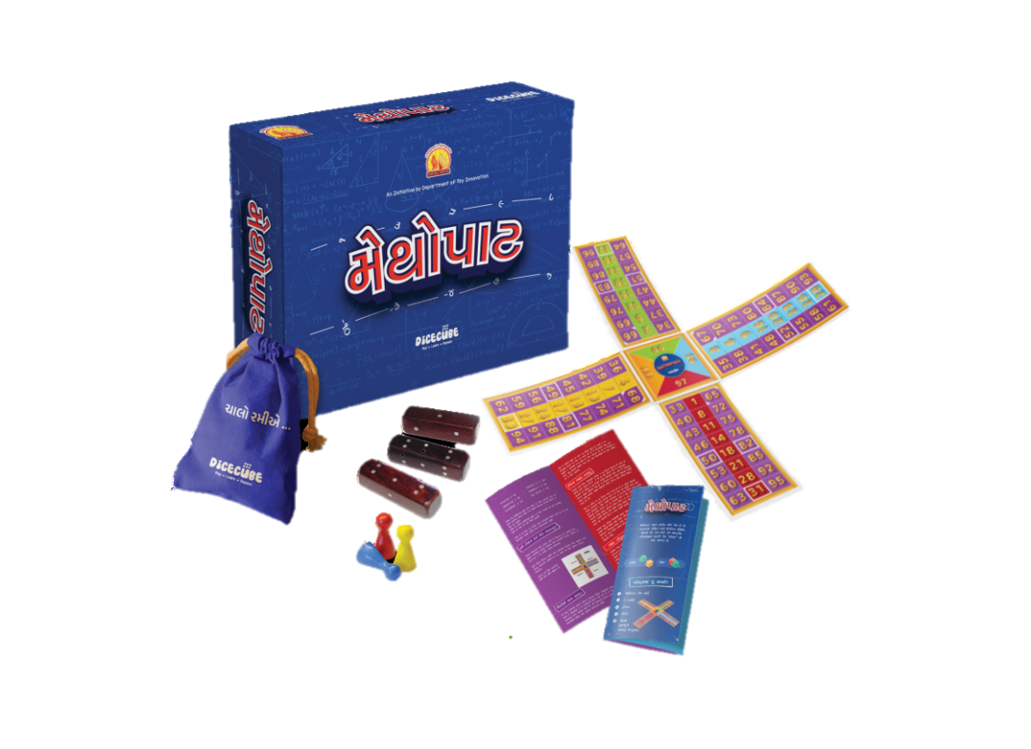 | Mathopat  Age Group : >08 Years  Learning Outcomes:  - Improved fluency in basic arithmetic operations  - Mental Math Skills  - Conceptual Understanding  - Goal Setting and Achievement  - Application of Math in Real-Life Scenarios  - Confidence in Mathematics
3 | 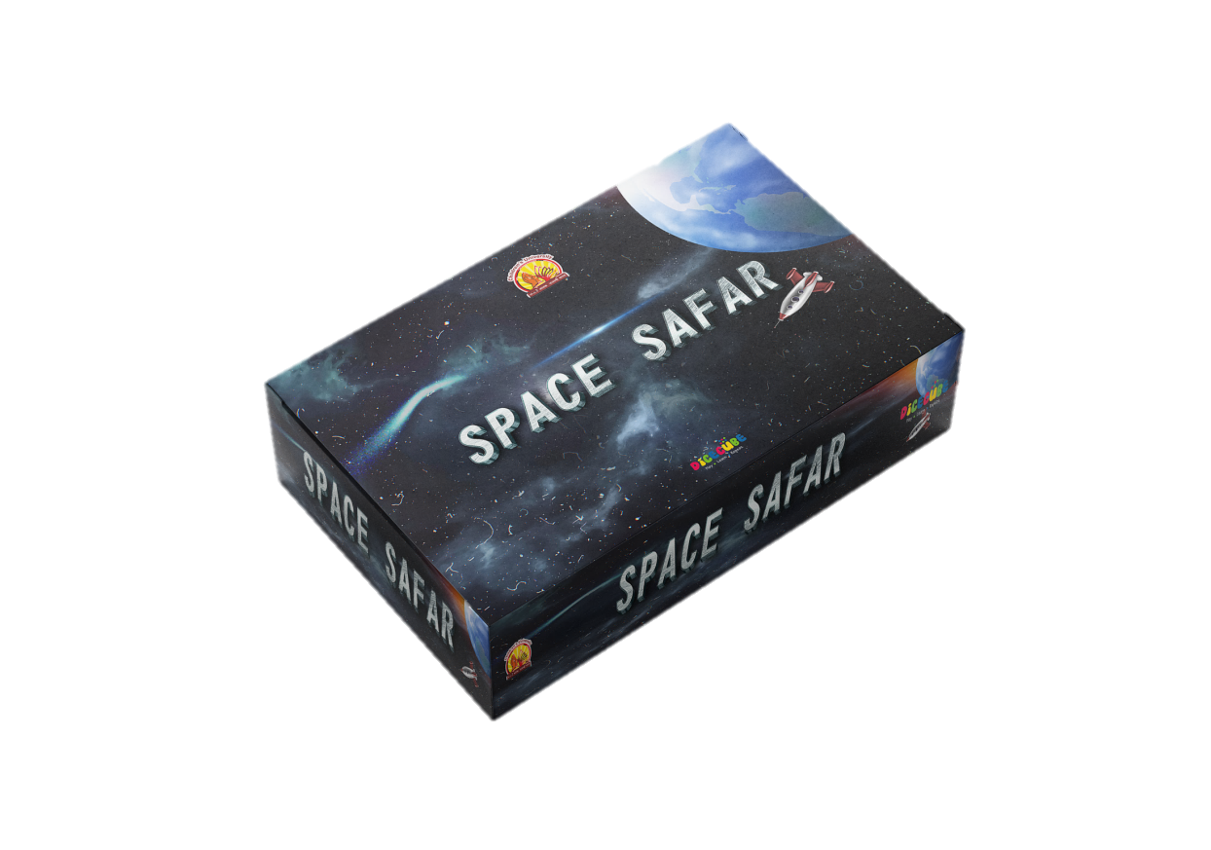 | Space Safar  Age Group: >8 Years  Learning Outcomes:  - Knowledge of the Solar System  - Resource Management  - Critical Thinking and Strategy  - Risk Assessment  - Quiz-Based Learning
4 | 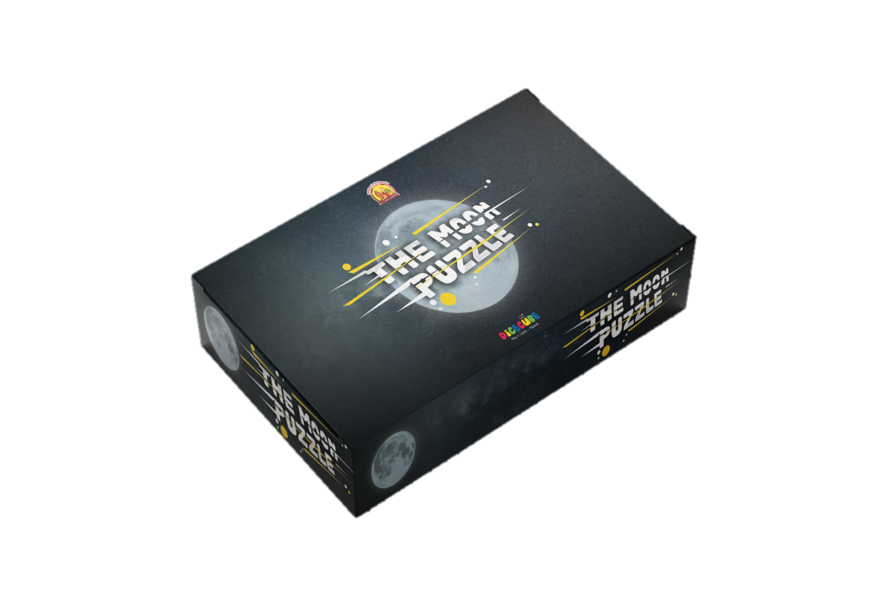 | The Moon Puzzle  Age Group: >8 Years  Learning Outcomes:  - Understanding Moon Phases  - Numerical Recognition and Counting  - Strategic Thinking  - Spatial Awareness  - Adaptability and Flexibility
5 | 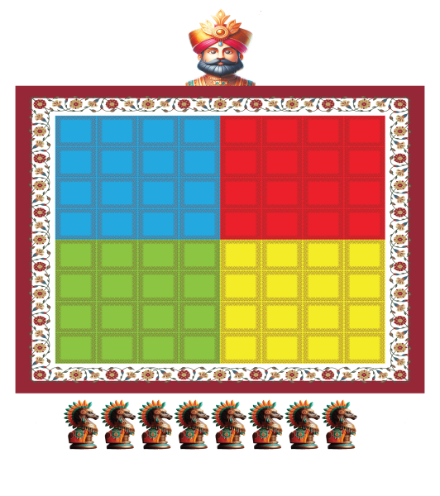 | Raja Mantri  Age Group : >08 Years  Learning Outcomes:  - Strategic Thinking  - Critical thinking  - Pattern Recognition  - Memory Enhancement  - Spatial awareness
6 | 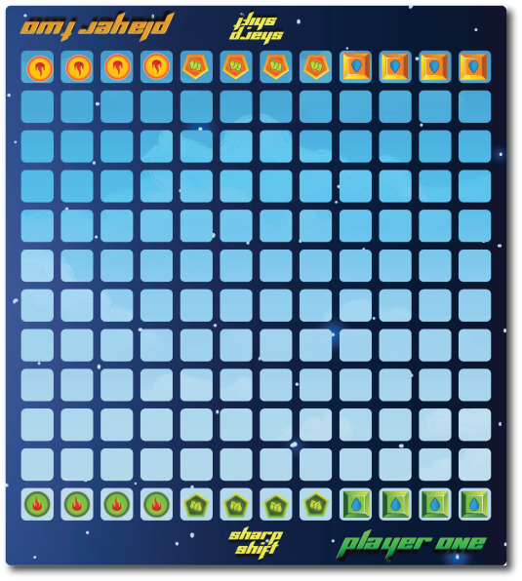 | Sharp Shift  Age Group : >08 Years  Learning Outcomes:  - Strategic thinking  - Tactical skills  - Spatial awareness  - Decision making  - Critical thinking
7 | 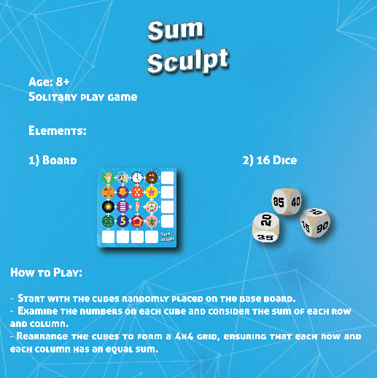 | Sum Sculpt  Age Group : >08 Years  Learning Outcomes:  - Learning Outcomes:  - Mathematical skills  - Critical thinking  - Stratergical thinking
8 | 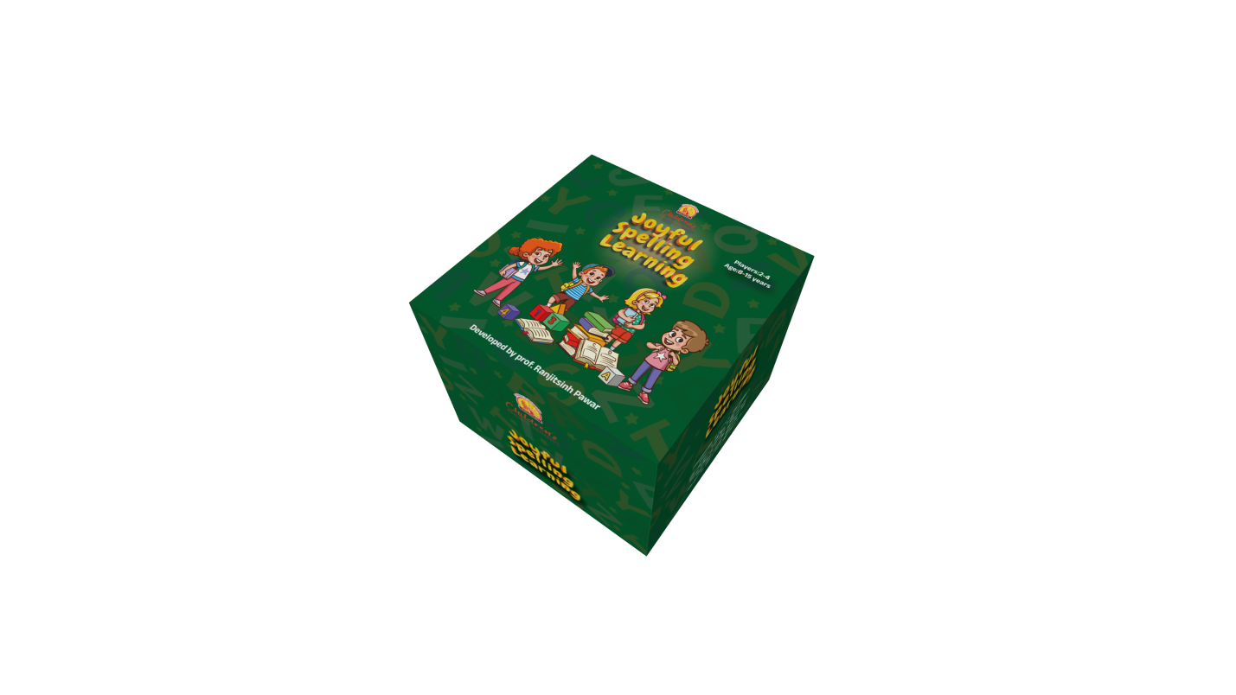 | Joyful Spelling Learning  Age Group : >08 Years  Learning Outcomes:  - Spelling and vocabulary building  - Word recognition and association  - Spelling will be memorized while playing  - Critical thinking and problem solving  - English language development, word formation, and spelling practice
9 | 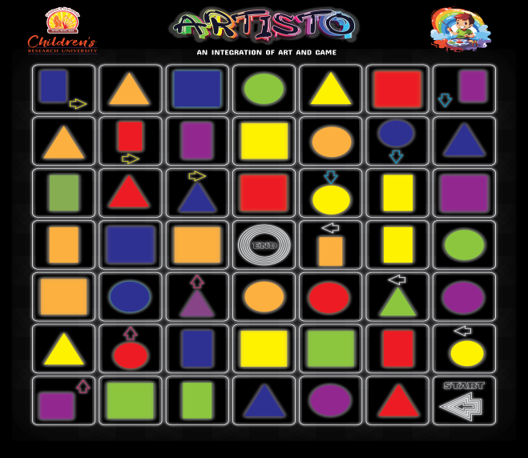 | Artisto  Age Group : >08 Years  Learning Outcomes:  - Creativity and imagination  - Color recognition and color theory  - Spatial awareness and planning  - Counting and numeracy  - Fine motor skill
10 | 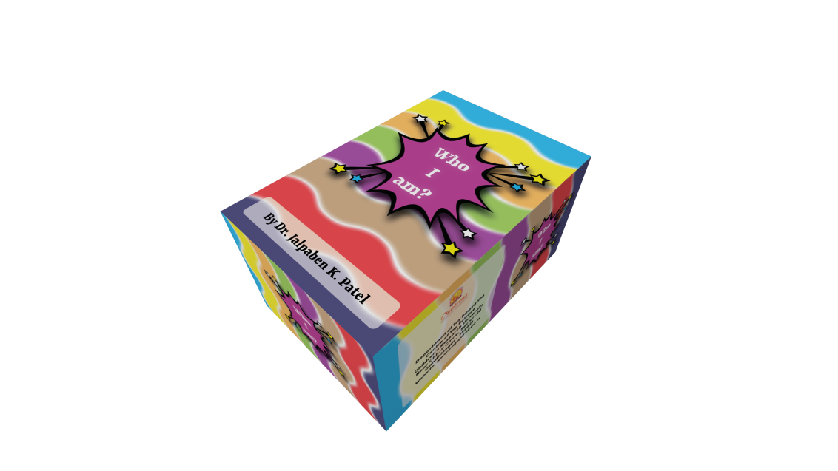 | Who I am?  Age Group : >08 Years  Learning Outcomes:  - Information about great personalities and historical places of India  - Increase memory  - Cultural consciousness  - Ability to work in a group - Increased confidence  - Increase vocabulary
11 | 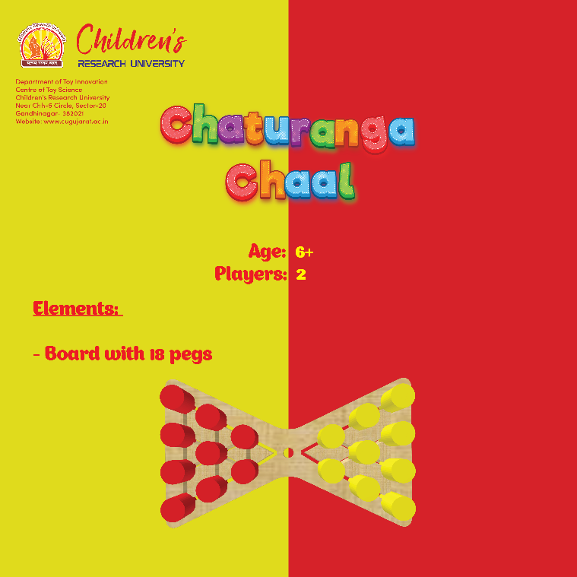 | ChaturangaChaal  Age Group : >08 Years  Learning Outcomes:  - Strategic thinking  - Decision-making  - Critical Thinking  - Patience and Perseverance  - Pattern Recognition  - Memory Enhancement
12 | 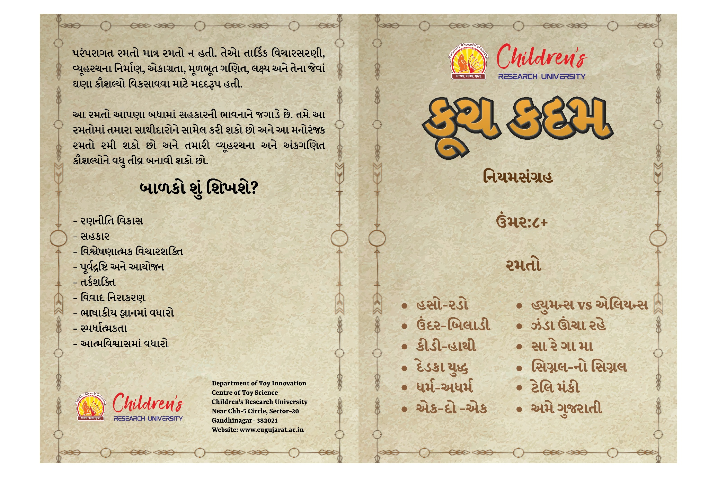 | Kuch Kadam  Age Group :>08 Years  Learning Outcomes:  - Strategy Development  - Collaboration  - Analytical Thinking  - Foresight and Planning  - Logical Thinking  - Conflict Resolution  - Increase in Self-Confidence

